**BTEC Assignment Brief**

|  |  |  |  |  |  |
| --- | --- | --- | --- | --- | --- |
| **Qualification** | | | Pearson BTEC Level 3 National Foundation Diploma in Information Technology | | |
| **Unit Title** | | | Unit 4: Programming 2 of 2 Programming Development | | |
| **Learning aim(s)/objective(s)** | | | Learning aim **B:** Design a software solution to meet client requirements  Learning aim **C:** Develop a software solution to meet client requirements | | |
| **Assignment title** | | | Unit 4: Authorised Assignment Brief for Learning Aims B and C - Programming Development (Version 1 September 2016) | | |
| **Assessor** | | | Peter Kay | | |
| **Start date** | | | 07/03/2022 | | |
| **Hand in deadline** | | | 21/03/2022 | | |
|  | | | |
| **Vocational Scenario (or Vocational Context)** | | **Scenario**  You are a junior employee at a small software development company. Your company recently visited a local college and delivered a guest lecture. The college were pleased with the outcome of the visit have asked your company to judge an upcoming tournament. You have been asked to design and develop a computer program to manage the scoring system for the tournament.  The college will be running a tournament for students to compete in a series of events for prizes.   * Participants may enter the tournament as individuals or as part of a team. * It is expected that will be 4 teams each with 5 members and there will be 20 spaces for individual competitors. * Each team or individual will complete 5 events. * Each event defined as a team or individual event. * The events will vary in type, from sporting to academic challenges. * Individuals and teams awarded points according to their rank within each event. * The points awarded for each event are yet undecided and the college are willing to hear any suggestions you may have. * Also, the college would like to include the possibility of entering for one event only   You have been asked to design and develop a computer program to manage the scoring system for the tournament. | | | |
|  | | | |
| **Task 1:** | | **Design (P4, P5, M2)**  Produce a design for the tournament scoring system application including clear and effective diagrams, illustrations and algorithm designs. You will produce a design report in which you will:   * Discuss software development life cycle stages, considering what areas of design and development should happen in which stages. You will produce an assessment of the scoring systems requirements and a design specification before any code is developed. * Document the design of the system you will create, including descriptions the tasks your program needs to fulfil, algorithms your program will use, data structures and data storage needed by the system. * You should ensure that all of your diagrams and illustrations are relevant and accurately describe the programs you intend to create. * Analyse the design options for the system, considering the features of the software you will create. * You should consider the advantages and drawbacks of using certain programming languages identify any pre-defined code and assets available for use and how it could be integrated into the new system. * Review your designs with others to obtain feedback and identify areas for improvement to evaluate and justify your final design. * Using appropriate methods, compile a test plan with test data for the system to be tested against once development is complete. | | | |
| **Task 2:** | | **Develop (P6, P7, M3, D2, D3)**  Following the design, you will develop the tournament scoring system application. You will implement the program to provide the functionality required by the college. You will produce a development report in which you will:   * Demonstrate your use of a development environment and the chosen programming language, including the use of any pre-defined code and library routines within your program identifying how they improve program efficiency. * Run your test plans from the design stage, ensuring that the program is thoroughly tested and that any errors found documented with reasons why the error occurred and suggestions for repair. * Repair errors found during the testing process with clear documentation for how repairs made and results of retesting. * Document errors that cannot repaired, giving reasons why this is the case and suggest repairs for future reference. * Review your program following feedback from users to identify areas for improvement and optimisation and prioritise which improvements to make with regard the time-frame available to you. * Evaluate your final product covering how the decisions from all stages of the design and development process have ensured that the computer program produced, in comparison to other possible solutions, resulted in solutions that fully meet the college's requirements and the impact these processes had on the effectiveness of the development of the final-outcomes.     You also need to show how you have taken individual responsibility and effectively managed yourself while completing this assignment. For example, you need to show how you have:   * Planned and managed your time and met targets. * Reviewed and responded to outcomes including the use of feedback from others * Behaved appropriately while completing the assignment – including professionalism, etiquette, supportive of others, timely and appropriate leadership, accountability and individual responsibility * Evaluated outcomes to help inform high-quality justified recommendations and decisions * Used appropriate methods of communication effectively | | | |
| **Checklist of evidence required** | | **You should include:**   * All of your design documents such as, diagrams, pseudo-code and illustrations. * Records of review discussions (what was discussed and what decisions were made?) * Test plans (what will be tested and how?) * Program code * Program files (your working program) * Test logs (results of your test) * Error reports (what went wrong and how it was fixed) * Optimisation logs (what was improved) * Your evaluation of the development and the completed program * A document which demonstrates that you have shown individual responsibility * and effective self-management | | | |
| **Criteria covered by this task:** | | | | | |
| **Criteria reference** | **To achieve the criteria you must show that you are able to:** | | | | |
| P4 | Produce a design for a computer program to meet client requirements | | | | |
| P5 | Review the design with others to identify and inform improvements to the proposed solution | | | | |
| P6 | Produce a computer program that meets client requirements | | | | |
| P7 | Review the extent to which the final computer program meets client requirements | | | | |
| M2 | Justify design decisions, showing how the design will result in an effective solution | | | | |
| M3 | Optimise the computer program to meet client requirements | | | | |
| D2 | Evaluate the design and optimised computer program against client requirements. | | | | |
| D3 | Demonstrate individual responsibility, creativity and effective self-management in the design, development and review of the computer program | | | | |
|  | | | | |
|  | | | | |
| **Sources of information to support you with this Assignment** | | | **Textbooks**  Stroustrup B. "Programming: Principles and Practice Using C++", Addison-Wesley Professional, 2014, 9780133796742  **Websites**  <http://1.droppdf.com/files/dkZRf/coding-for-beginners-in-easy-steps-basic-programming-for-all-ages.pdf>  <https://www.cs.princeton.edu/courses/archive/fall18/cos126/lectures/CS.1.Basics-2x2.pdf> | | |
|  | | | |

**LEARNER ASSESSMENT SUBMISSION AND DECLARATION**

When submitting evidence for assessment, each learner must sign a declaration confirming that the work is their own.

|  |  |  |  |  |
| --- | --- | --- | --- | --- |
| **Learner name: Rowan McNally Harrison** | | | **Assessor name:** Peter Kay | |
| **Start date:** 24/02/2022 | **Hand in deadline:** 21/03/2022 | | | **Submitted on:** |
| **Qualification:**  BTEC Level 3 National Foundation Diploma in Information Technology (21-22) | | | | |
| **Unit name(s):**  Unit 4: Programming | | | | |
| **Assignment title:** Unit 4: Authorised Assignment Brief for Learning Aims B and C - 2 of 2 Programming Development (Assignment 2) (Version 1 September 2016) | | | | |
| Please list the evidence submitted for each task. Indicate the page numbers where the evidence can be found or describe the nature of the evidence (e.g. video, illustration). | | | | |  |
| **Task reference** | | **Evidence submitted** | | **Page numbers or description** |
|  | |  | |  |
|  | |  | |  |
|  | |  | |  |
|  | |  | |  |
| Additional comments to the Assessor: | | | | |
|  | | | | |
| **Learner declaration**  I certify that the work submitted for this assignment is my own. I have clearly referenced any sources used in the work. I understand that false declaration is a form of malpractice.  Learner signature: Rowan McNally Harrison                                Date: 03/03/2022 | | | | |

**Mathematics Assessment Feedback (for** **embedded mathematics)**

|  |  |  |  |  |
| --- | --- | --- | --- | --- |
| **Mathematics Assessment** | | | | |
| Chose correct calculations independently | 3  All of the time | 2  Most of the time | 1  Some correct calculations chosen independently | 0  Unable to work independently to select calculations |
| Carried out calculations accurately | 3  All of the time | 2  Most of the time | 1  Some of the time | 0  Incorrect working out. |
| Used appropriate units  (MB, GB, KB, etc.) | 3  All of the time | 2  Units used accurately throughout the work | 1  Units used accurately some of the time. Some omissions or errors | 0  Units used are incorrect or units are not shown for most calculations |
| Work is set out in a logical way which shows methods used | 3  All of the time | 2  Most of the time | 1  Some of the time. | 0  Unable to work independently to show methods and logical calculations. |
| **Total** |  |

**Written Assessment (Feedback for embedded English)**

**Level 1, 2 and over**

|  |  |  |  |  |
| --- | --- | --- | --- | --- |
| **Written Assessment** | | | | |
| Work is clear, organised and is relevant for the intended reader | 3  All of the time | 2  Most of the time | 1  Some of the time | 0  Insufficiently clear, organised or relevant |
| Format is suitable for the reader and purpose (e.g. formal / informal / letter / email / report etc.) | N/A | N/A | 1  Yes | 0  No |
| Spelling (generally) including 100 generic words list | N/A | 2  Mostly accurate | 1  Some  Accuracy | 0  Not accurate |
| Words from ‘100 key words’ for vocational area are spelt correctly. | 3  All of the time | 2  Mostly accurate | 1  Some  accuracy | 0  Not accurate |
| Punctuation (including cap letters) | 3  Mostly accurate | 2  Reasonably accurate | 1  Some accuracy | 0  Insufficient accuracy |
| Grammar (tenses, sentence structure, subject verb agreement etc.) | 3  Mostly accurate | 2  Reasonably accurate | 1  Some  accuracy | 0  Insufficient accuracy |
| **Total** |  |

|  |  |
| --- | --- |
| ***Student Name:*** | Rowan McNally Harrison |
| ***Unit:*** | Unit 4 Programming Development |
| ***Tutor Name:*** | Peter Kay |
| ***Deadline Date:*** | 21/03/2022 |

|  |
| --- |
| 21 Most Popular Programming Languages in the World (and where to learn them) |

|  |
| --- |
| **Design (P4, P5, M2)**  Produce a design for the tournament scoring system application including clear and effective diagrams, illustrations and algorithm designs. You will produce a design report in which you will:   * Discuss software development life cycle stages, considering what areas of design and development should happen in which stages. You will produce an assessment of the scoring systems requirements and a design specification before any code is developed. * Document the design of the system you will create, including descriptions the tasks your program needs to fulfil, algorithms your program will use, data structures and data storage needed by the system. * You should ensure that all of your diagrams and illustrations are relevant and accurately describe the programs you intend to create. * Analyse the design options for the system, considering the features of the software you will create. * You should consider the advantages and drawbacks of using certain programming languages identify any pre-defined code and assets available for use and how it could be integrated into the new system. * Review your designs with others to obtain feedback and identify areas for improvement to evaluate and justify your final design. * Using appropriate methods, compile a test plan with test data for the system to be tested against once development is complete. |

**P4 Produce a design for a computer program to meet client requirements**

**Introduction:**

**SDLC:**

**Planning:  
  
Analysis:**

**Design:**

**Development:**

**Testing:**

**Implementation and Integration stage:**

**Maintenance:**

**Design 1:**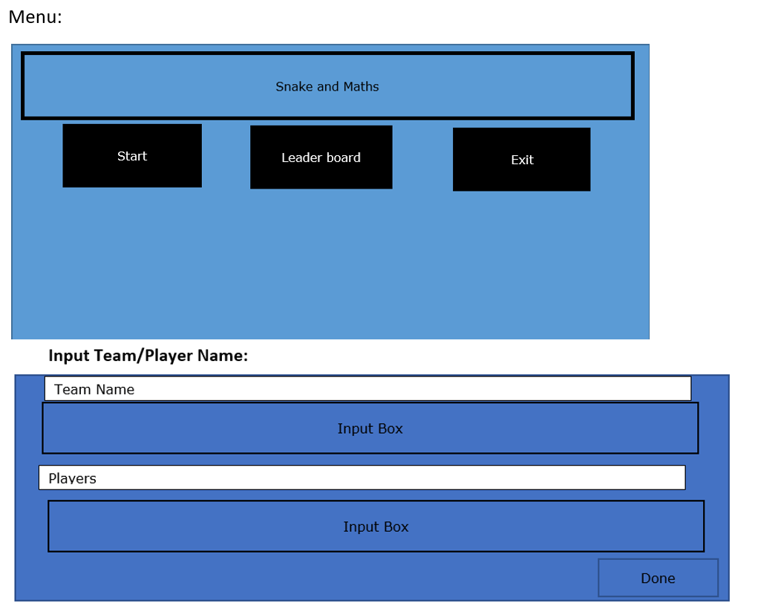

**Design 2:**

**Menus:**

